**Category:** Machine Learning, Deep Learning, Artificial Intelligence, cognitive psychology

**Job title:** Deep learning methods for sustainable development applications

**Contract:** Post-doctoral position **Contract duration:** 24 months

**Subject:**

In the current context of environmental changes, to reduce greenhouse gas emissions such as CO2, preserve biodiversity, reduce pollution, better manage water, etc., the solution is not solely technological. However, this does not mean that technology has no role to play. On the contrary, it can be an essential lever, provided it is used in a targeted and judicious manner. Today, the development of sustainable technologies is well understood, with examples such as the implementation of life cycle analysis [1]. To go further in eco-innovation [2] and address level 1 of the Tech for Sustainability axis, figure 1 in our eco-innovation approach, we must also ask: what are the specific areas where technology can have a significant positive impact to best help the ecological transition? To address this question, we aim to target the areas where the contribution of technology would be most significant. The question then becomes: in which areas will technology have the most impact?

1. 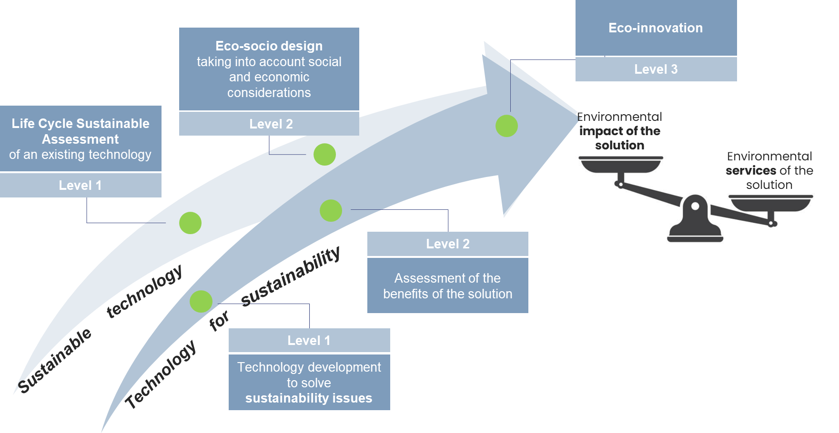
2. Figure 1 : Eco-innovation with two axes : sustainable technologies and technologies for sustainability.

The main objective is therefore to develop a methodology to help us target the application domains as well as the associated technologies that will best support this transition. To identify these priority domains, a starting point could be the work done by The Shift Project [3], which proposes sustainable solutions classified by industry sectors. This reference provides a solid foundation for evaluating the most relevant and feasible actions. There are other studies, such as those by ADEME [4]. However, these studies remain quite high-level, proposing, for example, to optimize water resources without prioritizing them. We aim to develop a methodology that allows us to define priority subjects both inter- and intra-domains, i.e., those that would be the most impactful as well as those that should be avoided. For example, we would like to know if it is more relevant to start with the agricultural sector rather than the energy sector, or if both should be pursued simultaneously. In the case where agriculture is the most impactful, should we prioritize technologies to promote agroecological practices or aim to reduce food waste through intelligent logistics solutions?

Since the impact of a technology also depends on how it is appropriated and used by potential future users, it is important to assess their perceptions—such as acceptability, usability, and desirability. For a review of technology acceptance models, see [5].

Guided by these questions, the research axes are as follows:

* Continuation of preliminary work on identifying solutions that aid the ecological transition, linking them with various AI components/technologies developed within the department.
* First-order or more in-depth evaluations of the positive and negative impacts of the identified AI technologies, and selection of the most relevant applications for the department's technologies.
* For the applications identified as priorities, conducting desirability studies in collaboration with LPNC.

**Applicant Profile**

The candidate should have completed a PhD in Computer Science, Machine Learning, or Signal Processing or cognitive sciences.

Knowledges and experiences in some or all of the following fields will be an asset during the position:

* Deep learning / Machine Learning
* Applied mathematics (probability / statistics)
* Cognitive psychology

A brief description of the PhD thesis, a publication list and some recommendations should be included to your application.

**Job location:** France, Grenoble

**Position start from September 2025**

**Contact**

Marina Reyboz, [marina.reyboz@cea.fr](mailto:marina.reyboz@cea.fr) , 04.38.78.27.68

**References**

[1] D. Bol, S. Boyd and D. Dornfeld, « Application-aware LCA of semiconductors: life-cycle energy of microprocessors from high-performance 32nm CPU to ultra-low-power 130nm MCU », in Proc. IEEE ISSST, 2011

[2] C. Sandionigi, J.-F. Berrée, M. Peralta, A. Piel, B. Robin, Sustainable technology and Technology for sustainability: The paths towards Eco-innovation, Electronics Goes Green 2024

[3] <https://theshiftproject.org/> ou dans le domaine de l’agriculture « Pour une agriculture bas carbone, résiliente et prospère », <https://theshiftproject.org/wp-content/uploads/2024/11/RF-Agri-Synthese-DEF.pdf>, 2024

[4] « Evaluation environnementale des effets directs et indirects du numérique pour des cas d’usages », <https://librairie.ademe.fr/economie-circulaire-et-dechets/7785-it4green-evaluation-environnementale-des-effets-directs-et-indirects-du-numerique-pour-des-cas-d-usage.html>, 2024

[5] Boris Alexandre, Emmanuelle Reynaud, François Osiurak, Jordan Navarro. Acceptance and acceptability criteria: a literature review. Cognition, Technology & Work, 2018, 20 (2), pp.165-177. https://doi.org/10.1007/s10111-018-0459-1